

FATİH DOĞAÇ
1901042654
CSE344 MIDTERM PROJECT
REPORT

- Introduction

This project is to design and implement a file server that enables multiple clients to connect, access, modify and archive the files in a specific directory located at the server side.
The project implemented as a server side and a client side programs

Server side :
neHosServer <dirname> <max. #ofClients>
the Server side is expected enter the specified directory (create dirname if the dirname does not
exits), create a log file for the clients and prompt its PID for the clients to connect. The for each
client connected will fork a copy of itself in order to serve the specified client (commands are given
on the client side). If a kill signal is generated (either by Ctrl-C or from a client side request)
Server is expected to display the request, send kill signals (requests) to its child processes, ensure
the log file is created properly and exit.

Client side :
neHosClient <Connect/tryConnect> ServerPID
the client program with Connect option request a spot from the Server Que with ServerPID and
connects if a spot is available (if not the client should wait until a spot becomes available,
tryConnect option leaves without waiting if the Que is full). When connected the client can
perform the following requests :
- help
display the list of possible client requests
- list
sends a request to display the list of files in Servers directory
(also displays the list received from the Server)readF <file> <line #>
requests to display the # line of the <file>, if no line number is given
the whole contents of the file is requested (and displayed on the client side)
writeT <file> <line #> <string>
:
request to write the content of “string” to the #th line the <file>, if the line # is not given
writes to the end of file. If the file does not exists in Servers directory creates and edits the
file at the same time
upload <file>
uploads the file from the current working directory of client to the Servers directory
(beware of the cases no file in clients current working directory and file with the same
name on Servers side)
download <file>
request to receive <file> from Servers directory to client side
archServer <fileName>.tar
Using fork, exec and tar utilities create a child process that will collect all the files currently
available on the the Server side and store them in the <filename>.tar archive
killServer
Sends a kill request to the Server
quit
Send write request to Server side log file and quits

- IPC (Inter Process Communication) Part

First of all, clients cannot tryConnect. I implemented a queue design and clients can only join to queue and wait.

Let me walk you through IPC part:
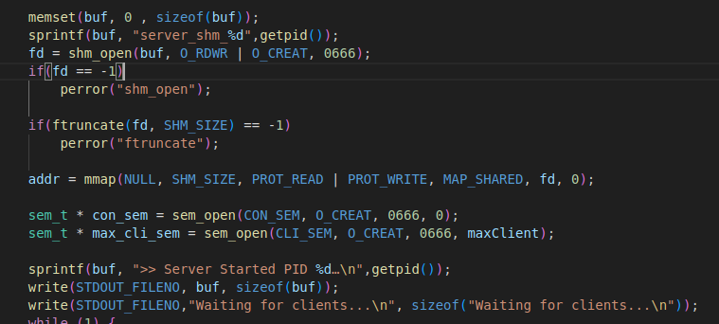

First, server creates a shared memory named “server_shm_{SERVER_PID}” and sets a size to it with ftruncate. Then mmap’s it. Then creates 2 semaphores:
con_sem is created for if two clients wants to connect the server at the same time, they will have to wait for con_sem. It stands for connection semaphore.

max_cli_sem is created to count current working clients. It starts with maxClient number and for each client that joins, it gets decremented by one.

Now, server started:
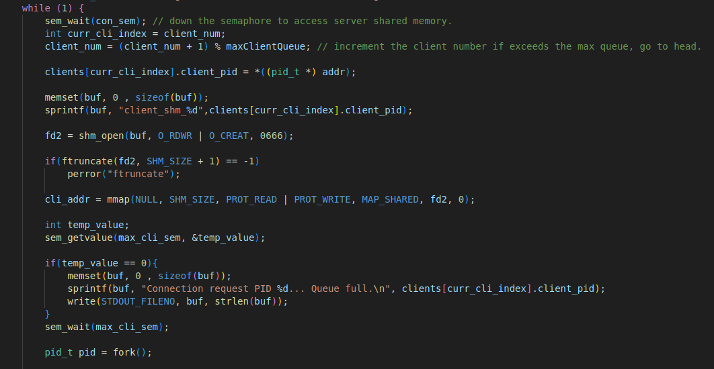
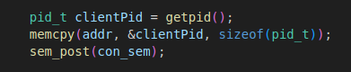
Client side:

Clients know about the connection semaphore(con_sem) and when a client joins, it posts the con_sem. And the server infinitely waits for clients with sem_wait(con_sem), if a client posts the con_sem, server forks itself and creates a child to attend to that specific client.

Before forking itself, server creates the client’s unique shared memory. And decrements the available slot number (max_cli_sem) by one.. So others will know one of the places is occupied.

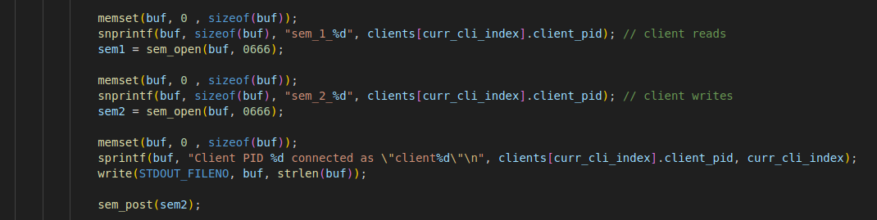
When the client connects, server opens its unique semaphores with client. (Server doesn’t create them, client does.) And posts the second unique semaphore (sem2) to notify the client that it has accepted to server.

And then server’s child enters an infinite loop for the client:
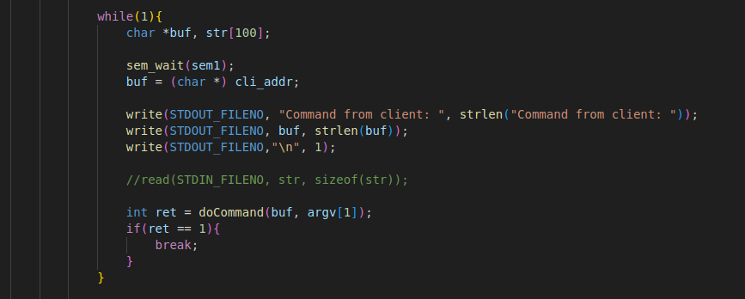
It basicly waits for sem1. When client increases the sem1, that means client wrote to the shared memory, server can read from it now.

Client:
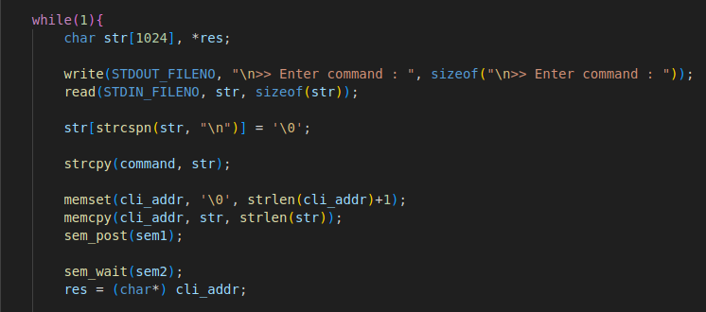

After server reads the command, it performs the doCommand() function. It is basically the main function of the child process.
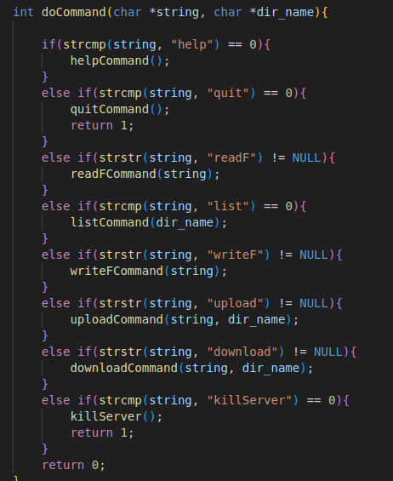

If we were to look into those functions:
Help:
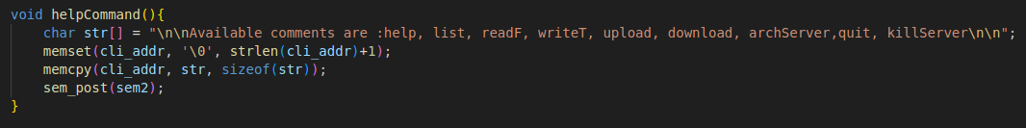
This is the most basic communication between server and client. There is a string and server writes this string to shared memory than notifies the client by incrementing the sem2.

Quit:
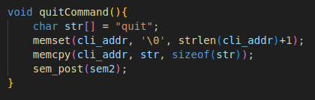
quit command notifies the user one last time. Then client performs its quit actions:
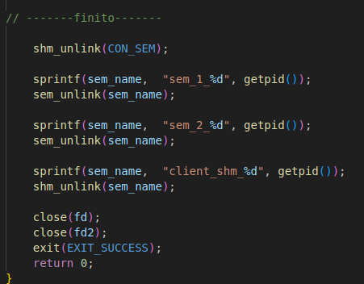

It cleans up the semaphores, shared memories and file descriptors. Then leaves

readF:
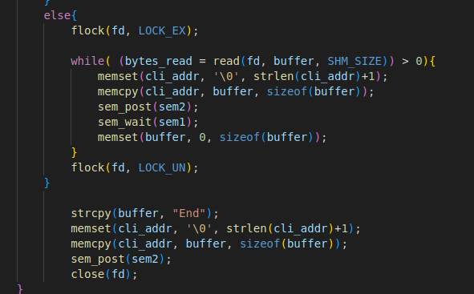
readF command, locks the file to be read, reads it SHM_SIZE at a time, which is 1024. Then it enters a loop with client and writes 1024 bytes at a time to shared memory.

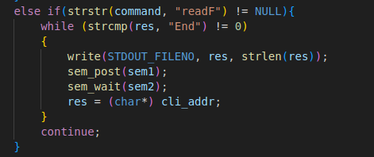

And client is reading from shared memory and prints it into their terminal until an “End” string is received. Then it exits from the loop and continues to enter commands.

WriteF:
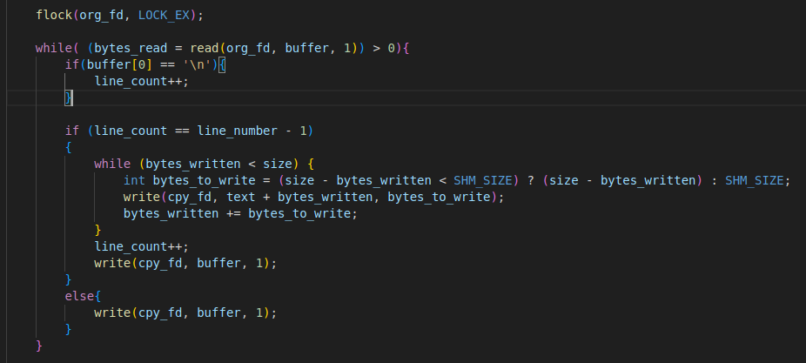

WriteF, reads from the file that specified. Creates a temp file and starts writing to it. Then when the given line number is reached it appends the given string. If there is no given line number, it appends to the end of file.

Upload:
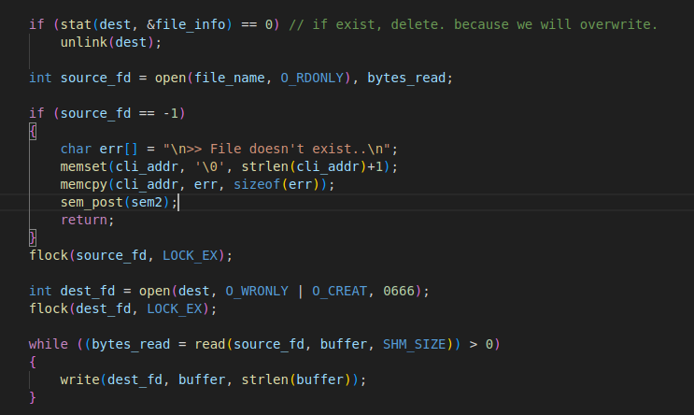

Upload doesn’t know about directories, it can only upload files in its current path. It basicly locks the file and if the file exists in the destination, it deletes the file to override. And then reads from source file and writes to destination file.

Download:
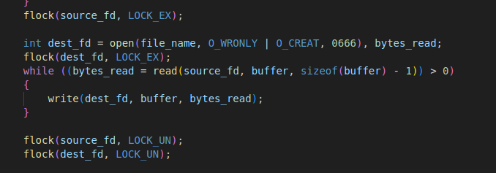
Download does the same but backwards.
KillServer:

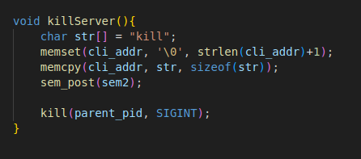

killServer, sends a string “kill” to client to let it exit on its own. If not no worries. It kills the parent process by signaling it SIGINT. So, SIGINT handler receives it.
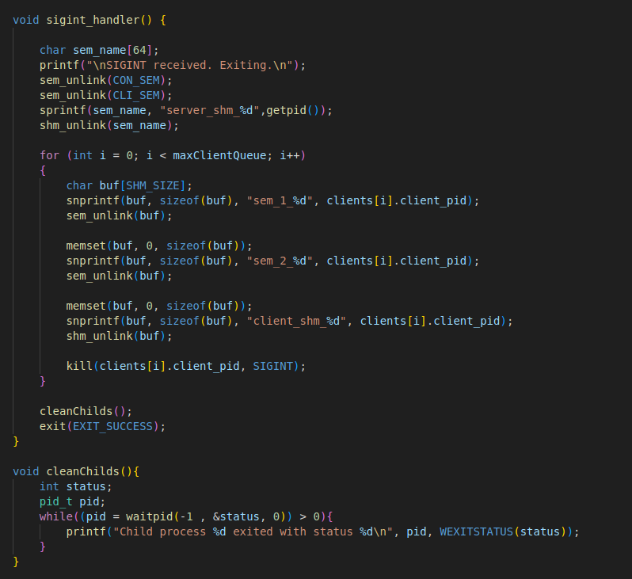
SIGINT handler, removes all semaphores of all clients, server’s semaphores, client’s shared memories and its own shared memory. Then sends a SIGINT signal to every client to let them exit. Then cleans the childs corresponds to those clients. So everything is cleaned up and ready to move on.

- Missing parts

  - Clients cannot tryConnect, they have to join to the queue.
  - There is no logging operation
  - There is no individual help command for each commands
  - Upload and download doesn’t work with complex branches, files have to be in the same path with the client.
  - ArchServer method doesn’t exists.

Example Usage That Demonstrates That The System Meets the Requirements:

Max Client number is 2 and Third client waits for one of the clients to exit.
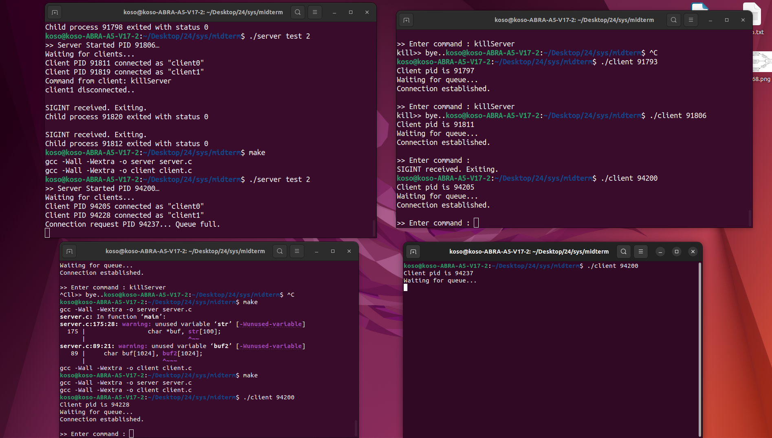

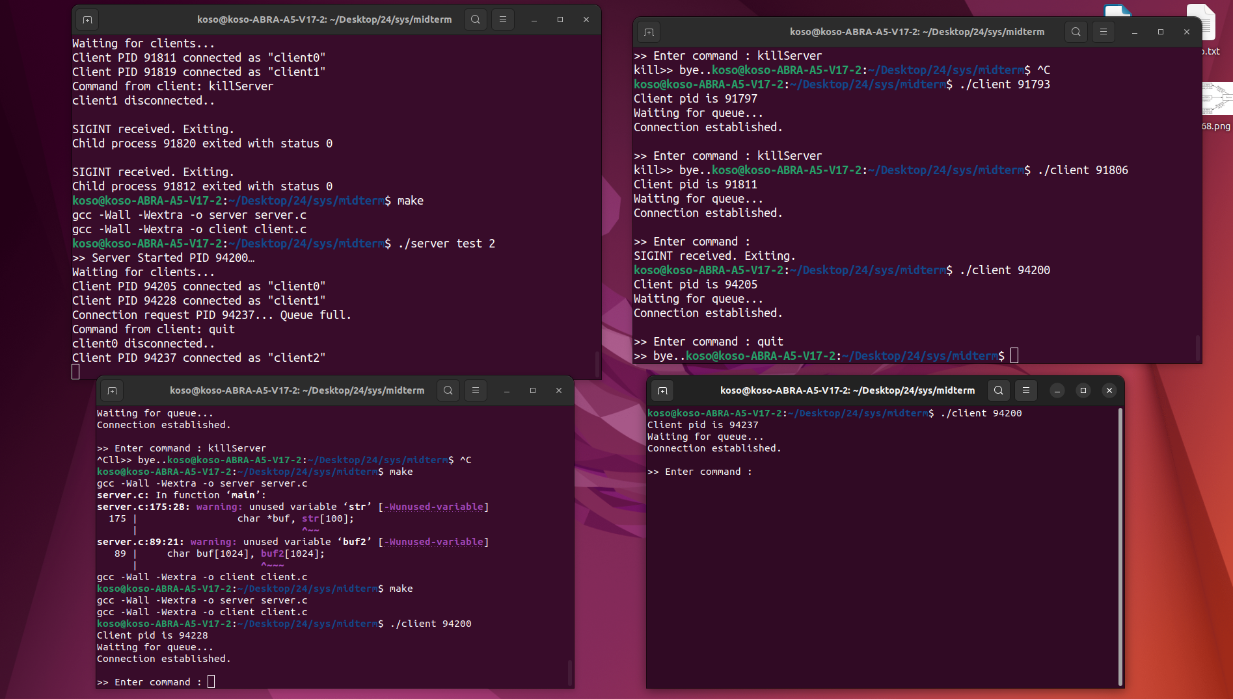
First client gone, third client in.

Help and list commands:
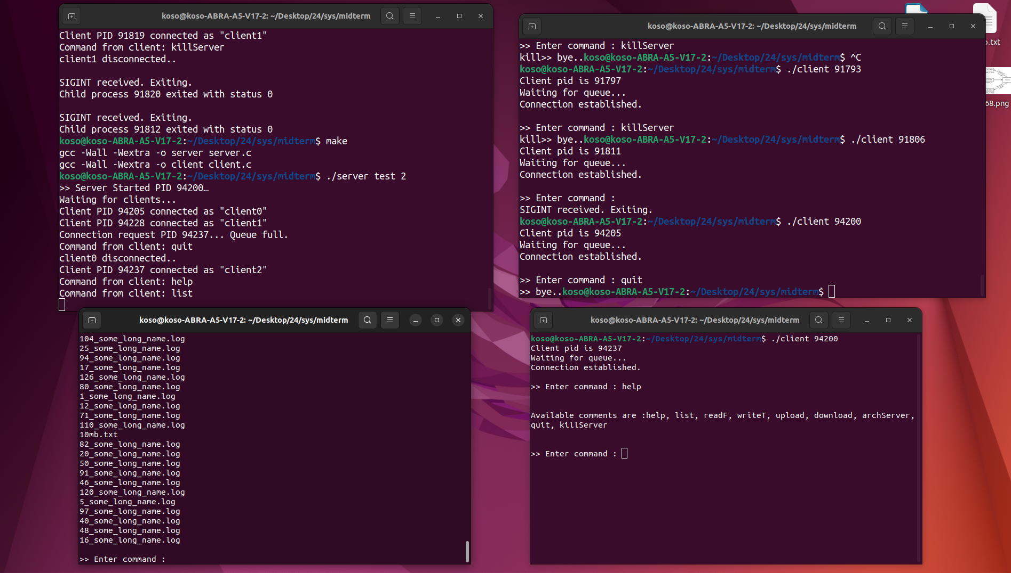

upload:
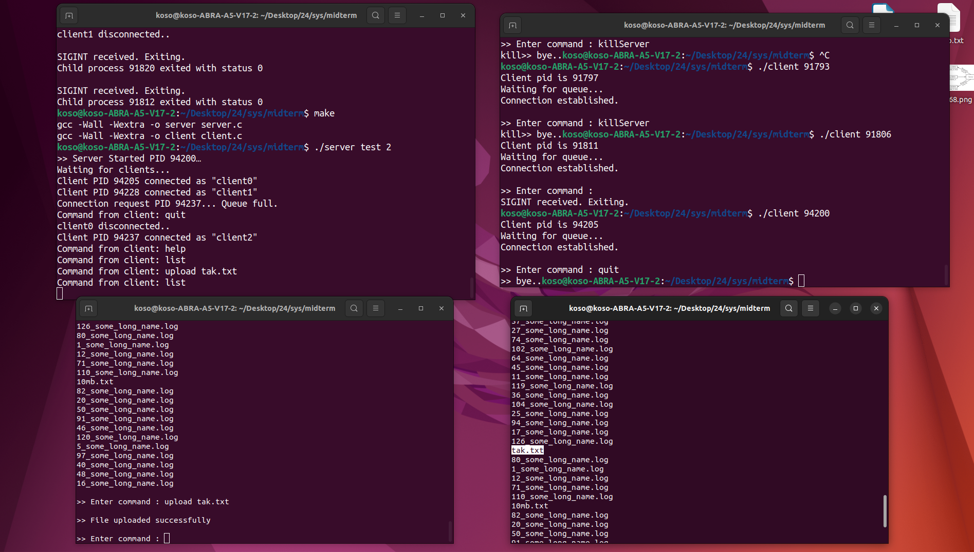
readF:



